Implementation of Machine Learning-Based Maximum Power Point Tracking for Wind Energy Conversion Systems

C. Balakrishna Moorthy1, Siddarth Sreeni1, Sahitya Tahiliani2

1Department of Electrical and Electronics Engineering, 2Department of Electronics and Instrumentation, BITS Pilani, K. K. Birla Goa Campus, India

Abstract

In this paper, a feasible and efficient algorithm to obtain the maximum power point (MPP) in wind energy conversion systems (WECS) for variable wind speeds by implementing machine learning (ML) into perturb and observe (P&O) algorithm is presented. This algorithm is simulated in python on a separately-excited DC generator. This model uses wind speed, humidity, temperature, pressure and generator speed to approximate a MPP by using ML at each iteration. From this estimated power point, the controller follows quick perturbation to calculate the maximum available power (MAP) and is used as training data for further estimation in the next iteration. This avoids over fitting or under fitting. The controller learns from this training set and estimates the MPP closer to the MAP which is updated again through perturbation and is recorded. The approximation of the MPP becomes more accurate whilst the time in further perturbation required for updating decreases. This model adapts to the versatile climatic conditions and variable wind speeds and yields an efficiency of 99.95% in predicting the MAP at the end of 1000 iterations corresponding to 2 hours 30 minutes.

Keywords: Wind energy conversion systems, Maximum power point tracking, Perturb and observe, Artificial intelligence, Machine learning.

# 1. Introduction

Majority of the energy requirements in today’s world are met with fossil fuels which are costly, non-renewable and pollute the environment. There is a necessity to switch to green energy resources. A lot of research is carried out in this area to find alternative energy resources that are renewable and can be easily harnessed. Existing such resources are solar and wind energy. Wind energy is a good alternative and is environmental friendly. Almost all regions throughout the world receive enough wind to produce energy on a large scale. Wind energy conversion systems (WECS) are of major importance in recent days [1]. There is a need to optimise the process of harnessing wind energy. An effective mechanism is required to efficiently harness maximum wind energy power. Since wind speed is continuously changing, it is difficult to extract a continuous and maximum power. Hence, there is a need to optimise power generation. An efficient and cost-effective system for capturing the maximum power is required. WECS consists of a wind turbine, charger controllers and an interconnection apparatus to supply the generated power from the wind to the transformers for further distribution. During windy periods, the wind cuts the blades of the turbine and causes the blades to rotate which generates a torque to the generator. Wind energy power output can be analysed based on the power (P) versus current (I) curve. The power-current characteristics under different wind speeds are shown in Figure 1.

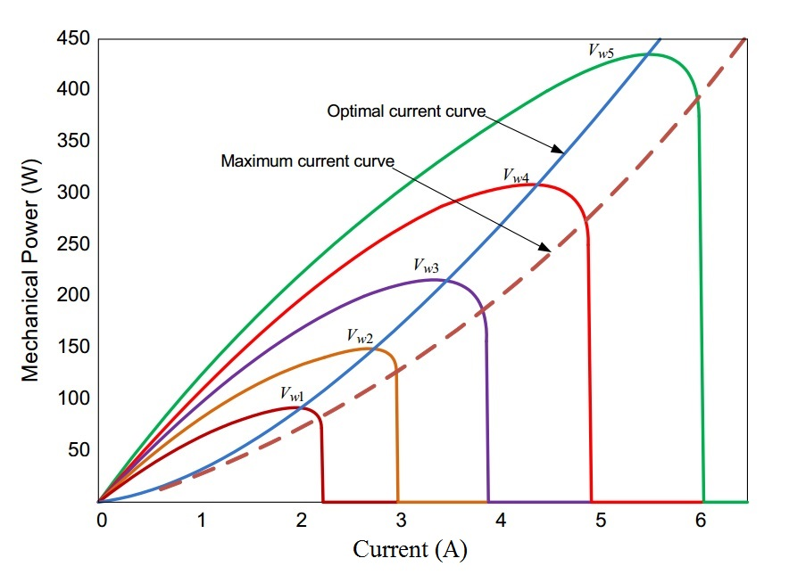

**Figure 1**. The Power Vs. Current under different wind speed [[2]](https://paperpile.com/c/grXGqI/hT99).

A load impedance is required for the generator to change the values of current and thus track the maximum power at different wind speeds. Since the graph plotted keeps shifting from its original position as the wind speed is changing continuously, this fluctuates the peak point of power. Therefore, the load impedance is required to be changed again to get the maximum power characteristic values for voltage and current. The process is known as Maximum Power Point Tracking (MPPT). MPPT is carried out by designing efficient charger controller for extracting maximum power from WECS. The charger controller is designed to control and optimize the generated power. Various methods like perturb and observe (P&O) [3], method of incremental conductance [4], method of fractional voltage [5], neural network [6] and fuzzy logic control [7], etc., are used in charger controllers to generate efficient power outputs. These algorithms have been compared on the basis of complexity, efficiency, performance, etc., and have been listed in Table. 1.

**Table. 1** : Comparison of  different MPPT techniques [[6]](https://paperpile.com/c/grXGqI/7R9W)

|  |  |  |  |  |
| --- | --- | --- | --- | --- |
| MPPT Technique | Convergence Speed | Implementation Complexity | Periodic Tuning | Sensed Parameters |
| Perturb and Observe | Varies | Low | No | Voltage |
| Incremental Conductance | Varies | Medium | No | Voltage, Current |
| Fractional Voltage | Medium | Low | Yes | Voltage |
| Fractional Current | Medium | Medium | Yes | Current |
| Fuzzy Logic Control | Fast | High | Yes | Varies |
| Neural Network | Fast | High | Yes | Varies |

In this paper, an alternative approach to overcome the limitations of existing methods is presented. The proposed design uses machine learning (ML) into perturb and observe methodology to estimate the maximum power point (MPP). ML is a type of artificial intelligence that provide systems the ability to learn without manually programming. It focuses on the developing software programs that can learn on its own and vary on exposure to new set of data. Results have been compared with the existing methods on the basis of efficiency and performance.

# 2. System Model:

Figure 2. describes the functioning of the proposed wind energy conversion system.

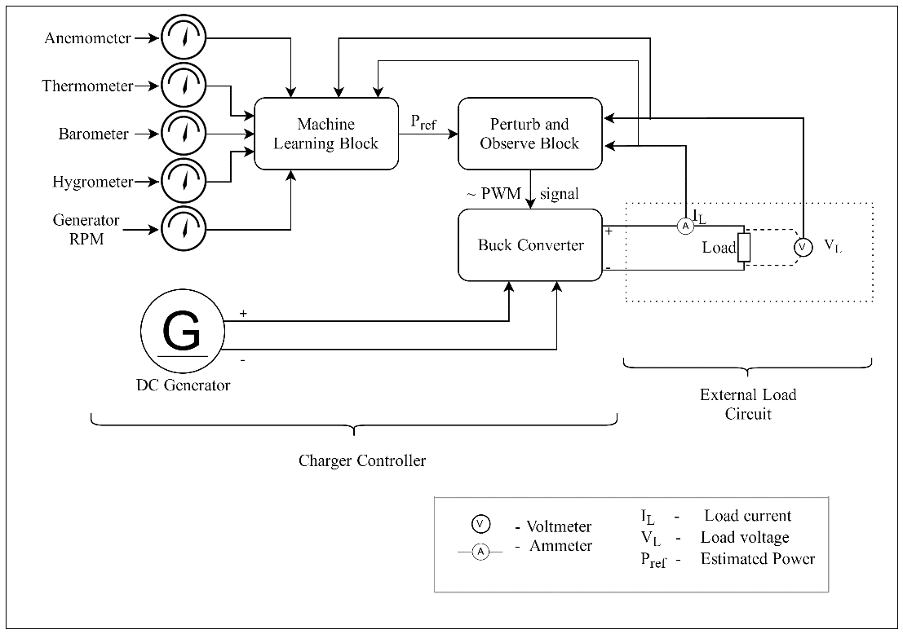

**Figure 2**. The configuration of wind energy conversion system.

The system comprises of buck converter coupled with a DC generator. It acts as a DC to DC converter that controls the proportion of input to output voltage by a pulse width modulation (PWM) signal via MPPT charger controller.

## 2.1 Separately excited DC generator Model

The wind energy conversion system transforms mechanical energy into electrical energy. The mechanical power (*Pm*) fed to the wind turbine is described as kinetic energy (KE) of the wind turbine rotor blade per unit time [[8]](https://paperpile.com/c/grXGqI/wQhw) as follows:

$P_{m}=\frac{KE}{t}=\frac{1}{2}ρAv^{3}$ (1)

Here $ρ$ is the air density, *A* is the area covered under the rotor blade and *v* is the wind speed (m/s). This is ideal power fed to the wind turbine. There is a theoretical limit to which this power can be utilized in practice. This limit is governed by Betz’s law [9], which illustrates the maximum power extractable from the wind turbine, independent of its design. According to Betz's law, no turbine can capture more than 59.3% of the kinetic energy of the wind. The generated power by the wind turbine depends on the efficiency factor, also known as coefficient of performance *Cp (λ, β)* of the wind turbine which depends on the pitch angle (*β*) and the tip speed ratio (*λ*). Tip speed ratio is the ratio of turbine speed to the wind speed and is given by:

$λ=ω\frac{R}{v}$ (2)

Here ⍵ is angular speed of the turbine and *R* is the radius of the turbine blade. Hence, the actual power (*P*) generated by the wind turbine is as follows:

$P=C_{p}\left(λ,β\right)P_{m }=\frac{1}{2}C_{p}\left(λ,β\right)ρAv^{3}$ (3)

The coefficient of performance has a maximum value of 0.593. The turbine’s coefficient of performance is a nonlinear function and is expressed by [10]:

+ 0.0035λ (4)

where β is the pitch angle and $\frac{1}{λ_{i}}$ is,

$\frac{1}{λ_{i}}=\frac{1}{λ+0.08β}-\frac{0.035}{1+ β^{3}}$ (5)

The characteristic curve for coefficient of performance *Cp (λ, β)* versus tip speed ratio (*λ*) for various values of the pitch angle (*β*) is shown below in Figure 3.

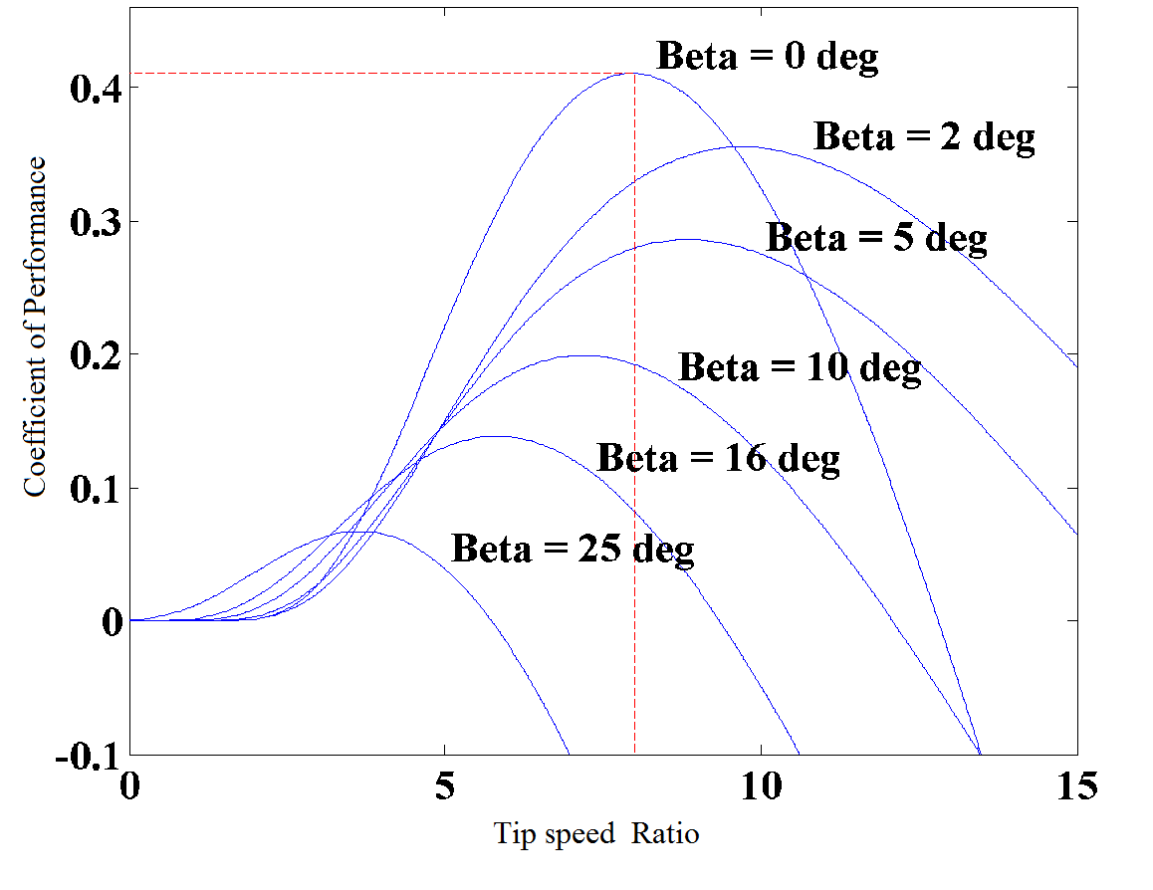

**Figure 3.**  Cp(,β) vs $λ$ characteristic curve for different β [11].

## 2.2 Buck Converters:

A Buck Converter [12] is a DC-to-DC converter that steps down the voltage whilst increasing current from the input supply to the output load. This device is essentially a switched-mode power supply typically containing minimum of two semiconductors (a transistor and a diode), a minimum of a capacitor, inductor, or a combination of both and is used for stepping down DC voltage. Buck converters are highly efficient (up to 90%), making them useful for various computational operations. A PWM signal is used for controlling the clock cycles of the stepping-down operation. A buck converter circuit is shown in Figure 4.

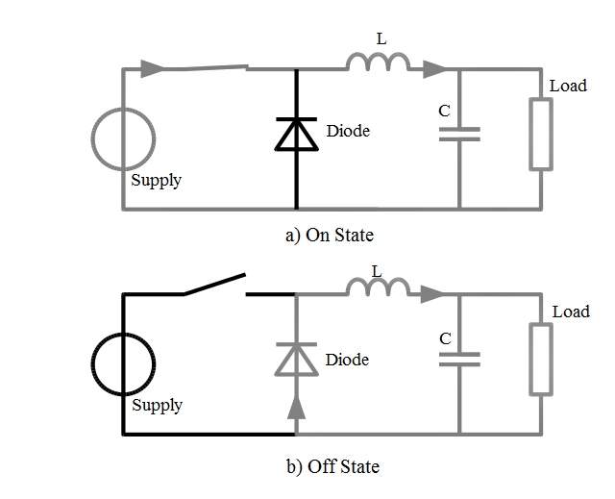

**Figure 4.** Different States of a buck converter [12].

## 2.3 Perturb and Observe:

Perturb and Observe (P&O) is the simplest and efficient method for MPPT in wind-energy conversion systems [13-14]. In this method, a controller adjusts the output power of the separately excited DC generator by controlling the duty cycle (PWM) of the buck converter, and measures the rise and fall in power continuously. If there is an increment in the power on increasing the duty cycle, then the duty cycle is increased further in the same direction. If there is a decrement in power, then the direction is reversed and the process is repeated in the opposite direction until there is no further rise in power. Hence the characteristic parameters of this point being the maximum power point are recorded and the optimum power is generated using them. This algorithm is frequently used in wind power generation due to its ease of implementation. A flow chart depicting the P&O algorithm using a buck converter is shown in Figure 5, where Pi is the calculated power in the current iteration and Pi-1 is the power output for the preceding iteration. The algorithm ends with sorting the obtained maximum available power (MAP) from P&O to the input variables (pressure, temperature, generator RPM etc.) and appending the ML algorithm which is explained in section 2.4.

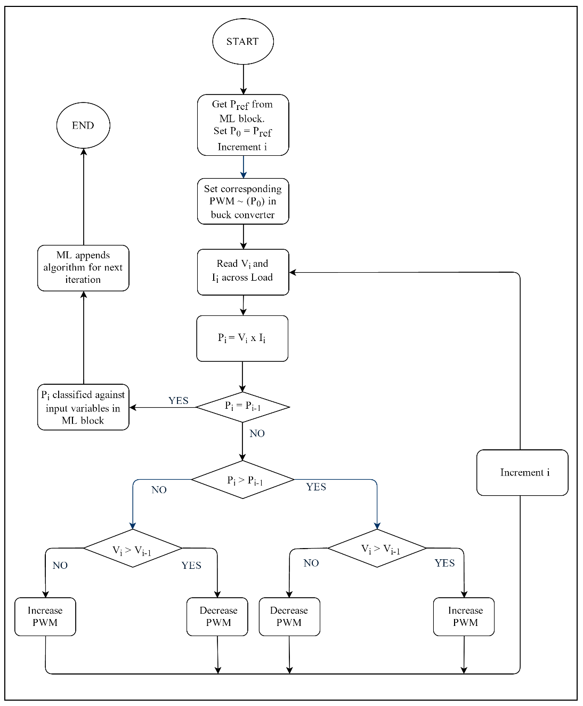

**Figure 5**.  Flowchart depicting P&O algorithm.

## 2.4 MPPT Algorithm:

The proposed method is a modified approach to perturb and observe. The process of Machine Learning (ML) is similar to data mining, however the obtained results from the older data are used to estimate results for the new data. Hence, an artificial intelligent supervised learning technique is being used in this paper. The machine learning algorithm used in this model estimates a power point close to the MAP using a localised linear regression model based on characteristic parameters (*bk* as given in Eq. (7)) of previously observed MPP(s) and current wind speed, humidity, pressure, temperature, and generator RPM. The proposed system is a causal system. This model generates an algorithm and recognizes patterns in the formation of the MPP(s). As time progresses, the feedback updates the estimation algorithm. The system recognizes more patterns and refines the regression model parameters as in Eq. (7) and Eq. (8).

$ϕ_{t}= F_{t}(ϕ_{0},..,ϕ_{t-1})$ (6)

Here *ϕt* is the MPP at time *t*. The ML algorithm is represented as *Ft* for ease of understanding. It is the estimation function at time *t* using the dataset of MPP(s) at previous iterations (*ϕ*0.... *ϕ*t -1) and the characteristic variables as in Eq. (7). The obtained result is passed on to the next block as *Pref* and the algorithm follows regular P&O to obtain the MPP (*Pt*) using a synchronous Buck DC- DC converter. A linear regression model is generalized by the following formula. The prediction of 𝑌𝑖 is computed by Eq. (7) [15].

$Y_{i}= b_{0}+b_{1 }X_{1k}+…+b_{k}X_{ik}+ϵ_{i}$ (7)

Where, $b_{k }$ are the regression coefficients, *Xik* are the regressor variables or the input variables and  is the error at iteration *i*. $Y'$ is the mean of all the predicted values of $Y_{i}$ (MPP) using variable inputs $X_{ik}$ and with*k* predictor variables. The $b_{i }$ values are called regression weights and are computed in order to minimize the sum of squared deviations shown in Eq. (8). *N* is the number of iterations.

$\sum_{i=0}^{N}{{(Y_{i}-Y^{'} )}^{2}}$ (8)

# 3. Experimental Results

A graph between MAP and predicted MPP is shown in Figure 6. This illustrates the estimated power point which is passed as *Pref* = (*ϕt*) and MAP (*Pt*) obtained at the end of each iteration.

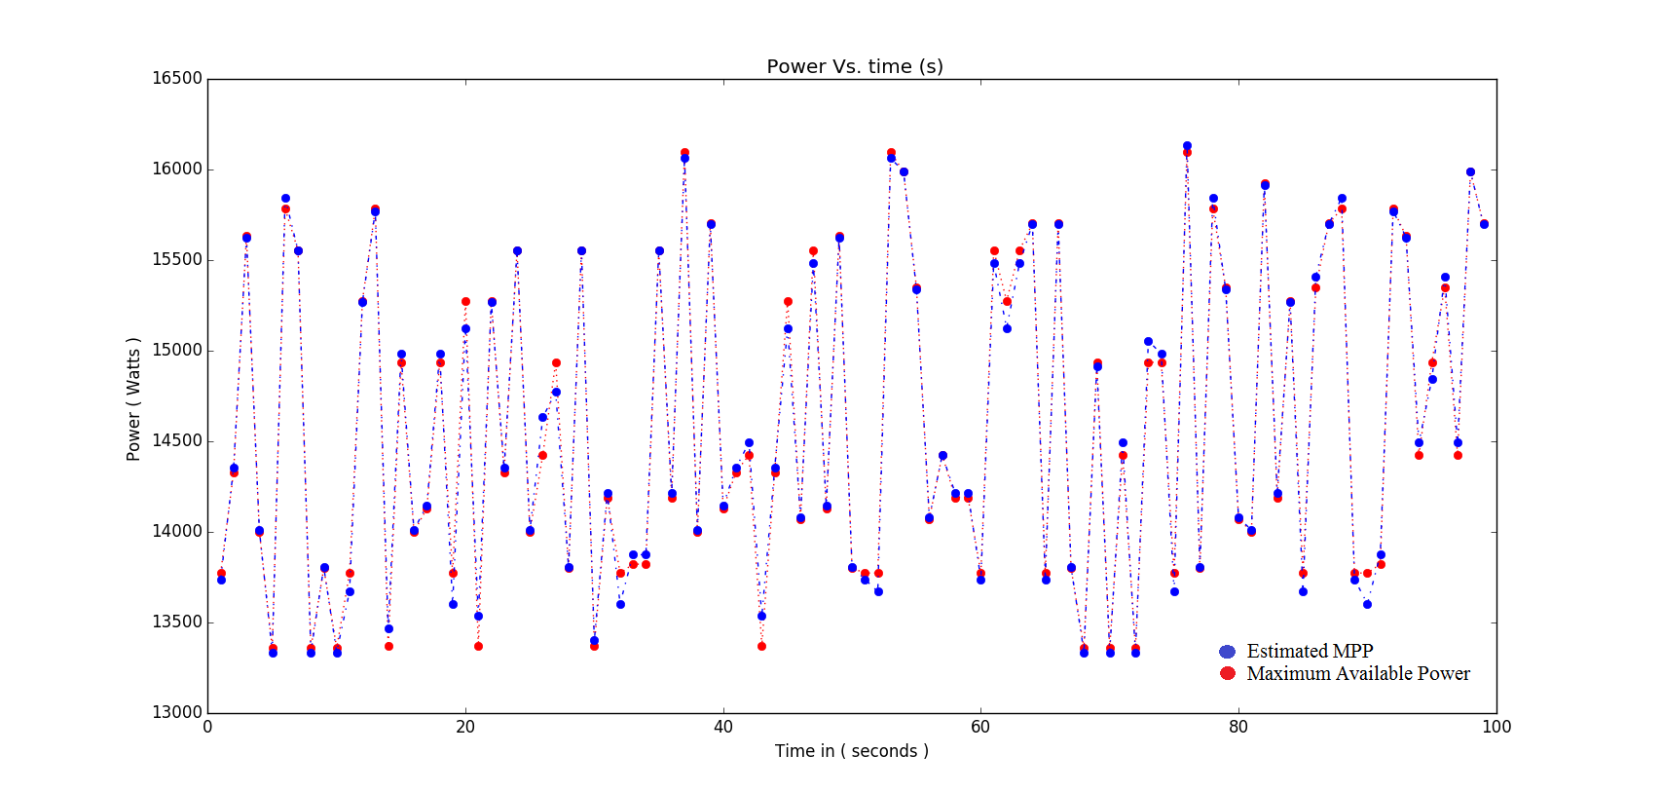

**Figure 6.** Comparison of estimated Power *ϕt* (blue) and maximum available power (MAP) *Pt* (red).

The prediction of function 𝐹𝑡 to the actual MPP (*P𝑡*) is much more accurate to *F*𝑡−1. Figure 7 shows the mean error in estimating the same value after each iteration. It is evident that the error is decreasing. After each iteration, the system fits more patterns and the error obtained decreases with time. Hence, the system learns.

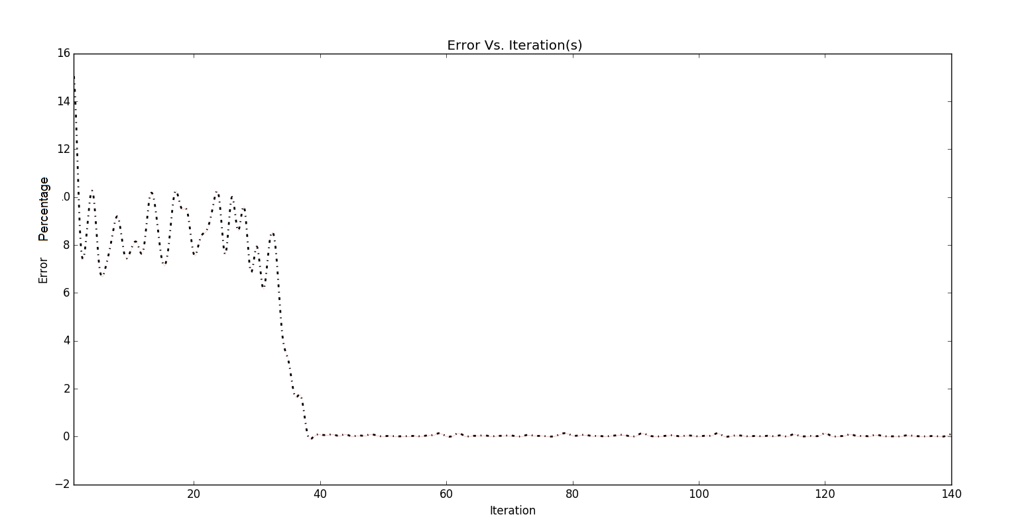

**Figure 7**. Mean error at each iteration.

From Figure 8, the eﬃciency of the proposed MPPT model at 1000 iterations is greater than 99.95% for estimating the MPP. Hence, the proposed MPPT algorithm is highly adaptive, eﬃcient and eﬀective. The percentage error (*∆*) is as follows:

$Δ=\left|\frac{100\left({P_{t}- ϕ}_{t}\right)}{P_{t}}\right|\%$ (9)

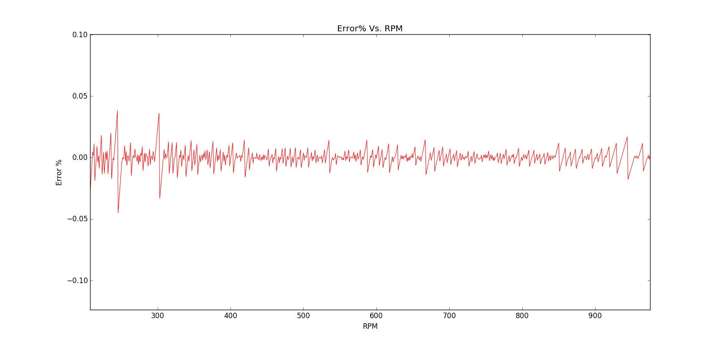

**Figure 8.** Percentage error at each RPM of the DC generator at time t = 2.5 hours or 1000 iterations.

The Figures 9 and 10 show the dynamic responses of the generated voltage and current obtained from the proposed MPPT algorithm with respect to time. In this domain, a validation dataset obtained from P&O is fed back, after each iteration into the training data, this limits the errors from increasing. Thus, machine learning overcomes overﬁtting that usually occurs in other artificial intelligent algorithms such as artiﬁcial neural networks (ANN) and other fuzzy logic based control systems.

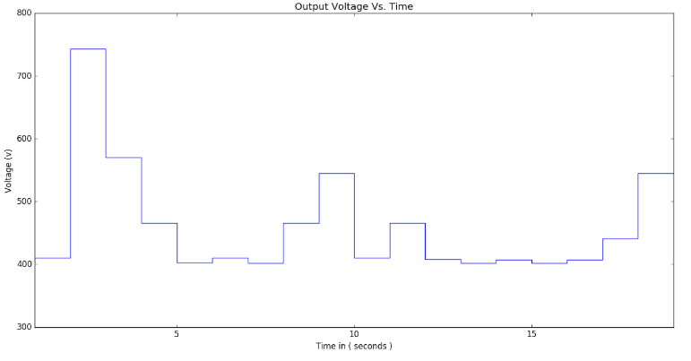

**Figure 9**. Output Voltage based MPPT control.

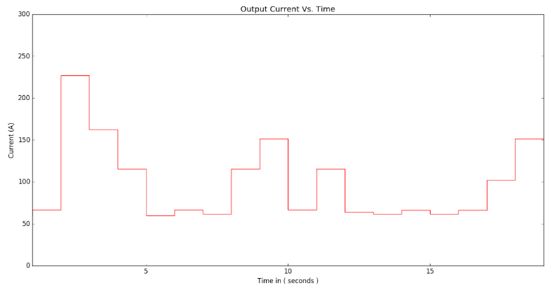

**Figure 10.** Output Current based on MPPT control.

The Figures 6 - 8 show the advantages of using machine learning into perturb and observe. The estimation technique implemented overcomes many of the issues faced in existing MPPT algorithms. These include better performance, faster convergence, ease of implementation and higher precision in estimation.

**4. Conclusion**

In this paper, an intuitive method to track maximum power point during hasty and rapid weather changes is described. A python simulation of a wind energy conversion system with a DC load has been carried out to validate the proposed MPPT method. The results showed that the proposed MPPT method tracked the MPP with insignificant fluctuations. Observations show that the performance and accuracy of the proposed algorithm is not affected by alterations in load. The perturbation time increases during unexpected wind speeds, but the proposed algorithm gradually learns and adapts to the new weather conditions. The main advantages of the proposed MPPT control method are faster convergence to the MPP, robustness, higher efficiency and its ease of implementation. The system is a modified algorithm of P&O and can be cascaded to the existing P&O equipment with convenient setup and resulting in better efficiency

# References:

[1] B. K. Sovacool, “The importance of comprehensiveness in renewable electricity and energy-efficiency policy”, *Energy Policy, vol. 37, no. 4, pp. 1529–1541, 2009.*

[2] K. Chatterjee and D. Kumar, “A review of conventional and advanced MPPT algorithms for wind energy systems,” *Renewable and Sustainable Energy Reviews, vol. 55, pp. 957–970, Mar. 2016.*

[3] M. A. Elgendy, B. Zahawi, and D. J. Atkinson, “Evaluation of perturb and observe MPPT algorithm implementation techniques,”*6th IET International Conference on Power Electronics, Machines and Drives (PEMD 2012), 2012.*

[4] T. Boutabba, S. Drid, L. Chrifi-Alaoui, M. Ouriagli, and M. E. H. Benbouzid, “SPACE real-time implementation of maximum power point tracking based on ripple correlation control (RCC) structure for photovoltaic system,” *2016 5th International Conference on Systems and Control (ICSC), 2016.*

[5] S. M. Ferdous, M. A. Mohammad, N. Farhan, A. M. Saleque, and M. A.Z.M.Shahriar, “Design and simulation of an open voltage algorithm based maximum power point tracker for battery charging PV system*,” 7th International Conference on Electrical and Computer Engineering, 2012.*

[6] T. Esram, E. Trishan, and P. L. Chapman, “Comparison of Photovoltaic Array Maximum Power Point Tracking Techniques*,” IEEE Trans. Energy Convers., vol. 22, no. 2, pp. 439–449, 2007.*

[7] A. V. P. Kumar, A. V. Pavan Kumar, A. M. Parimi, and K. Uma Rao, “Implementation of MPPT control using fuzzy logic in solar wind hybrid power system,” *IEEE International Conference on Signal Processing, Informatics, Communication and Energy Systems (SPICES), 2015*

[8] A. Soetedjo, S. Aryuanto, L. Abraham, and W. P. Mulayanto, “Modeling of wind energy system with MPPT control*”, International Conference on Electrical Engineering and Informatics, 2011.*

[9] M. Ragheb and M. Adam, “Wind Turbines Theory - The Betz Equation and Optimal Rotor Tip Speed Ratio”, *Fundamental and Advanced Topics in Wind Power, 2011.*

[10] M. Azzouz, A. Maher, E. Abdel-Latif, and E. Hasan, “Adaptive critic design-based regulation of the DC-bus voltage in wind energy conversion systems”, *49th IEEE Conference on Decision and Control (CDC), 2010.*

[11] Zou, Y., Elbuluk, M., & Sozer, Y. (2010, October). “A complete modelling and simulation of induction generator wind power systems". *Industry Applications Society Annual Meeting (IAS), 2010 IEEE (pp. 1-8). IEEE*.

[12] M. Brown and B. Marty, “Switching Power Supply Topologies”, *Practical Switching Power Supply Design, pp. 17–42, 1990.*

[13] E. Koutroulis and K. Kalaitzakis, “Design of a maximum power tracking system for wind-energy-conversion applications,” *IEEE Trans. Ind. Electron., vol. 53, no. 2, pp. 486–494, 2006.*

[14] H. Gitano, G. Horizon, T. Soib, and K. Mohammad, “Design and Testing of a Low Cost Peak-Power Tracking Controller for a Fixed Blade 1.2 kVA Wind Turbine*,” Compatibility in Power Electronics, 2007.*

[15] T. Hill, P. Lewicki, and P. Lewicki, “Statistics: Methods and Applications: A Comprehensive Reference for Science, Industry, and Data Mining”. *StatSoft, Inc., 2006.*